**Mafiatopia**

1. Concept

In Mafiatopia, there are many different gangs, they are all suppliers of necessary ingredients and unique formulas. And, of course, the gangs want to exclude each other to become the only supplier to make a lot of money.

1. Gameplay

Players will take turns clockwise. First, roll a 6-sided dice to choose the zone to place your color icon in that zone[A]. Next, use the ability card if you have one. Take action or use tokens to buy materials in that zone/other players. Can only do 1 of 2. If there is someone in the same zone, the decision can be made to fight or not. If you attack, use 6-sided dice and 4-sided dice. Subtract the small number from the higher number to determine how much HP the attacked person loses. The turn is over, and it's the next player's turn.

1. A game box and cards on a table

   Description automatically generatedA game board with cards and a box

   Description automatically generated with medium confidenceOriginality

From "Shadow Hunter" and "7 Wonders"

1. Innovation

- Theme: The Gangs Theme gives the player a unique story background. Meanwhile, Shadow Hunter has a good faction and an evil faction, there is an additional neutral faction, and 7 Wonders is the theme of famous wonders worldwide.

- Multiple Winning Conditions: The game will end when the last player has HP left, or a player has crafted the last stage of the Recipe card. Every player will count points [C]. The winning condition of Shadow Hunter is that only one side wins (Hunter or Shadow), and Neutrals have their own missions on character cards. In 7 Wonders, the person with the most points wins by taking materials to collect points.

- Recipe Cards: Players are required to collect the ingredients contained in the card, and they must have a strategy to enter the rooms with those ingredients. Neither Shadow Hunter nor 7 Wonders have this mechanic.

1. Influences

- Dice-Based Movement and Combat: Mafiatopia is based on rolling 2 dice (large number minus small number) to attack from the board game Shadow Hunter. But, while Mafiatopia only needs 1 6-sided dice to move.

- Character Cards: similar to Shadow Hunter in that they have HP and 7 Wonders, and each city creates its materials. Mafiatopia has combined both of these mechanics to create character cards

- Resource Management: players collect ingredients and buy ingredients with tokens similar to 7 Wonders.

- Ability Cards: similar to the mechanic of stacking White and Black cards in Shadow Hunter.

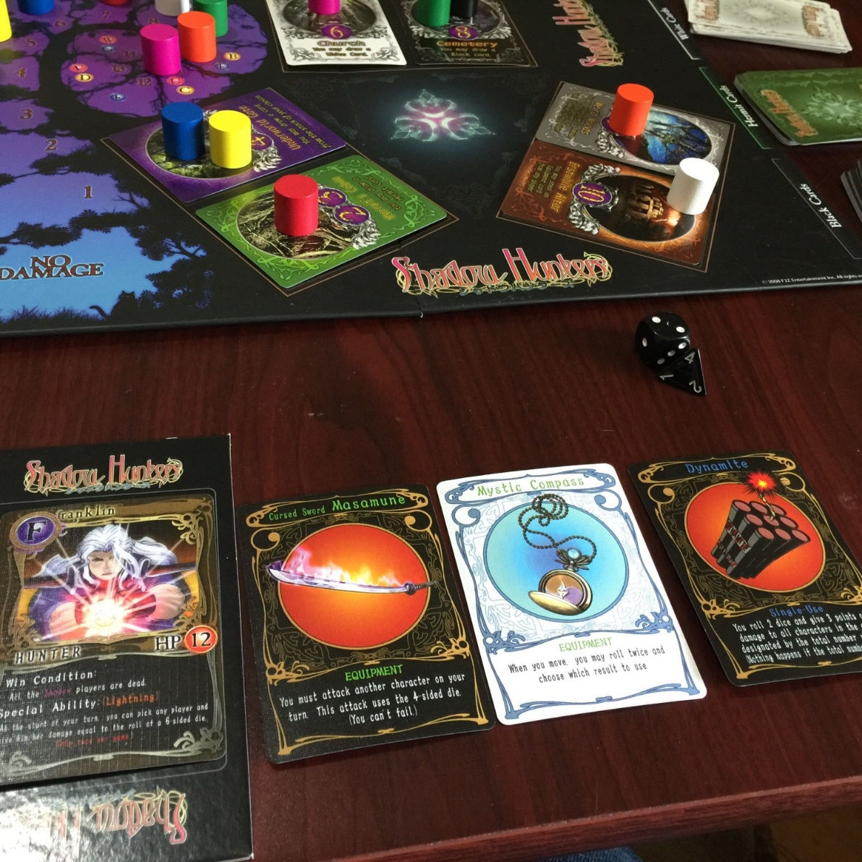

- Game Board: HP column and zones perform the same actions as Shadow Hunter, but Mafiatopia has added zones that sell materials.

1. Target Audience [B]

13+

1. Genre

Card Crafting, Party Game, Dice.

1. Components

* Game Board: There is an HP column for all gangs and different zones.
* Recipe cards: In 1 of the 2 winning conditions of the game, the player must collect the ingredients in the card.
* Ingredient cards: players must collect the necessary ingredients.
* Ability cards: equipment cards to buff players
* Action zone cards: placed on the board so players can perform actions
* Character Cards: will have HP and symbols of materials that the gang can create themselves
* Tokens: buy and sell materials
* 6-sided dice and 4-sided dice: large numbers minus small numbers to attack opponents

1. Game Loop

1. Setup

Place the action cards on the board in the right place, take the pile of ingredients, shuffle them, and take 3 cards from each zone. That will be the material that that zone sells. The remaining pile of ingredient cards and the pile of abilities cards are set aside.

Deal character cards, recipe cards, and 10 coins to each player (The remaining coins will be placed in the Bank area) [D].

Place the color icons the player has chosen, one in the HP column and one in front of the zones.

1. Two purposes [E]

* Craft the recipe.
* Kill all other gangs.

**Appendix**

[A] Roll a 6-sided dice to choose the zone to place your color icon in that zone.

At first, the player must randomly roll a 6-sided die to enter the area. But I realized that my area only has 5 rooms. What if the player rolls the number 6? At that time, I plan to add one more area to make the area complete, or when the number 6 is rolled, the player can go into any area. However, Long Hoang commented that I should minimize the game's Randomization. He explained that if the player already knows how to play randomly, the player who wins will still win the next time they play, and the player who loses will still lose the next time. This will lead to the game being boring.

So, I fixed each player to lose 1 coin to enter the area they wanted. This will reduce Randomization as much as possible.

[B] 16+

After testing the game and deciding on my art style in Mafiatopia, I decided to change from 16+ to 13+. My art style is cartoon, not realistic. Furthermore, my game does not have intense violence. Players only attack by rolling dice to reduce the opponent's health.

[C] Mafiatopia has 2 different winning conditions: kill all other players and create recipes with ingredients.

Mafiatopia still retains the game's purpose of crafting Recipe cards and killing other players. But in the end, you have to count the points to find the winner. Mafiatopia has been tested with the other two winning conditions. Most players choose to kill other players to win the game quickly without wasting time crafting Recipe cards. Because to make the game more balanced, players will win by calculating points.

[D] Tokens to each player

After testing the game with coins and transactions, I edited each player to receive 10 coins at the beginning of the game, and the remaining coins will be placed in the Bank area. Furthermore, Mafiatopia has added a new area dedicated solely to storing coins, the Bank area.

[E] One of two Win Condition

Because the game has been changed to whoever has the most points wins, crafting the recipe and killing other players will be the two goals of Mafiatopia.

**Mafiatopia – Rule Book**

- Game name: Mafiatopia

- Number of players: 4 to 12

- Playing time: 30 to 60 minutes

- Age: 13+

**Table of contents**

1. Introduction

2. Content

3. Game elements

4. Game setup

5. Transaction

6. End of the Game

7.  Credits

**Introduction**

"Mafiatopia" is a board game that brings together many notorious gangs who want to eliminate each other to survive. Each gang provides a different ingredient. Will they become friends or competitors?

**Content**

1 Game board

5 Action cards (Area cards)

20 Character cards

30 Ability cards

25 Recipe cards (Win Condition cards)

80 Ingredient/ Material cards

1 Rule book

1 six-sided dice

1 four-sided dice

24 Player Pawns

150 value 1 coins

80 value 3 coins

**Game Elements**

Board games

One side is the character's HP index. The other side is the area. Players can move into this area.

Each area needs one action card (area card) and three random ingredient cards to complete the area.

Action cards (Area cards)

The card will display area numbers 1 - 5 to set up the correct room number.

Players are required to pay 1 coin if they want to enter that room.

Along with that is the content of Action. The player is required to perform this Action.

Character cards

Each card will display information about that character.

+ Name

+ Name of gang

+ HP

+ Self- supply ingredient

Ability cards

Ability cards will have two types (this will be recorded on the card), and this card is always used that turn. One type can be used continuously, and the other can only be used once.

With one-time use, players can save it until their next turn to use it.

Recipe cards (Win Condition cards)

There will be steps to create a particular item on the Recipe card. Each recipe card has its recipe and is not the same.

Each player will only receive one recipe card for the whole game.

Ingredient/Material cards

Each card will represent one or more ingredients. The player will collect these cards. If there are two or more ingredients in 1 card, you must choose 1 of 2. For example, your Recipe card needs 2 wood, but you only have 1 card of wood, you have to buy another wood from the area or from other players

There is no limit to the number of Ingredient cards.

This card can be sold and is worth three coins/card. This money will be put into the bank.

Player Pawns

Each player will have 2 Player Pawns of the same color. One pawn will represent the character's HP, and the other pawn will be used to move into areas.

Coins

Coins help players trade with other players in buying and selling materials.

Players own an unlimited number of coins.

Coins can be converted into points at the end of the game.

Coin value 1 cent = 1 point

Coin value 3 cents = 3 points

**Game Set-up**

- Place the Action cards in the correct area in the order on the card from 1 to 5, and randomly divide three ingredient cards into each area. If the ingredient card is the same as one in other areas, draw randomly to get another card.

Each player is randomly dealt 1 Character Card, 1 Recipe card and 2 Player Pawns of the same color. (Character card and Recipe Card must be drawn randomly).

- The Player Pawn representing the player is placed in the "Start" spot in the HP area

- When the game starts, each player will receive ten coins. Place the remaining amount in the Bank area.

- Place the stack of Ability Cards and Ingredient/Material cards into its area.

**Playing the game**

Each person's turn will be clockwise.

When it is their turn, players will do these actions in turn:

1. Enter that Area (Mandatory) (a)

2. Choose 1 of the following two actions: (Mandatory) (b)

- Buy ingredients in that Area (b1)

- Do the actions in the Action card (Area card) (b2)

3. Use Ability card(Optional)

4. Attack other players (Optional) (c)

a. You pay 1 coin to go into the room you want. However, you cannot stay in the same Area in your next turn.

**Note:** If you run out of money, sell your Ingredient card. Think carefully about the card you will sell.

b. After moving, you must do 1 of 2 actions.

b1. Each Area has been divided into 3 ingredients. You have to pay 2 coins to the bank to buy 1 of those 3 ingredients. Each time you enter the Area, you can only buy 1 ingredient.

b2. Do action on that Area's Action card.

c. You can attack a player in the Area where you are standing. Roll both 6-sided and 4-sided dice to attack. Subtract the smaller number from the bigger number to get the amount of HP the attacked person lost. (For example, if you roll 4 on a 4-sided dice and 3 on a 6-sided dice, take 4-3 = 1, the attacked person must subtract 1 health from the HP area on the game board)

Each turn will repeat until the game ends.

**Transaction**

* To enter a area: 1 coin
* Buy ingredient in area: 2 coins
* Sell Ingredient Card: 4 coins
* Buy ingredient from other gang who owned that ingredient: 3 coins

**End of the game**

The game ends when a single player has HP remaining or a player has finished crafting the last stage of the Recipe card. At this time, all players sit and count their points, and if they craft a recipe to any stage in the Recipe card, the points for that stage will be counted.

Points are calculated by adding the total points in the Recipe card, coins, remaining health (if possible).

**Credits**

Game Designer: Tracy

Art: Tracy